**19CE083**

Perform the task in today's lecture.

**Task1: Using Handlebar, create HTML page that contains following information**

1. Subject-Code, Subject-Name (Text-box)
2. Institute-Name (Text-box)
3. Department-Name (Text-box)
4. Semester=>Dropdown menu

**Task2: Store above information into MySQL database and display**

**File- Structure: -**

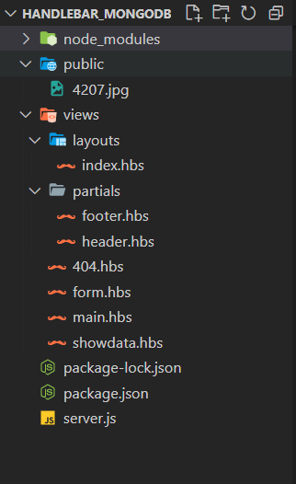

**Code: -**

1. **server.js**

const express=require("express");

const PORT=3000;

const app=express();

const handlebars=require("express-handlebars");

var mysql = require('mysql');

//connection

const connection = mysql.createConnection({

    host: 'localhost',

    user:'root',

    password:'',

});

connection.connect((err)=>{

    if(err) throw err;

    console.log("Connected successfully to MySql server")

});

//create database

const dbquery="CREATE DATABASE IF NOT EXISTS Subject";

    connection.query(dbquery,(err,result)=>{

        if(err) throw err;

        console.log("Database created successfully",result)

    })

//create table

    const dbtable=`CREATE TABLE IF NOT EXISTS subject(

        subjectCode varchar(10) NOT NULL,

        subjectName varchar(50) NOT NULL,

        instituteName varchar(50) NOT NULL,

        departmentName varchar(50) NOT NULL,

        semester varchar(1) NOT NULL,

        PRIMARY KEY (subjectCode))`

        // SHOW DATABASES => List the available DB from MySql server

    connection.query("USE Subject",(err,result)=>{ // "Select Database"

        if(err) throw err;

        connection.query(dbtable,(err,result)=>{

            if(err) throw err;

            console.log("Table created successfully",result)

        });

    });

    //middleware

app.use(express.static("public"));

app.use(express.urlencoded({extended:false}));

app.set('view engine', 'hbs');

app.engine("hbs",handlebars({

    layoutsDir:`${__dirname}/views/layouts`,

    extname:"hbs",

    defaultLayout:"index",

    partialsDir:`${__dirname}/views/partials`

}))

app.get("/",(req,res)=>{

    res.render("main");

});

app.get("/subject-form",(req,res)=>{

    res.render("form");

});

app.post("subject-form",(req,res)=>{

    res.redirect("/show-data")

});

app.post("/show-data",(req,res)=>{

    // console.log(req.body);

    var subjectCode = req.body.scode;

    var subjectName = req.body.sname;

    var instituteName = req.body.iname;

    var departmentName = req.body.dname;

    var semester=req.body.sem;

    var sql = `INSERT INTO subject (subjectCode, subjectName, instituteName, departmentName, semester) VALUES ("${subjectCode}", "${subjectName}", "${instituteName}", "${departmentName}","${semester}")`;

    connection.query(sql, function(err, result) {

        if (err) throw err;

        console.log('record inserted');

        res.render("showdata",{data:req.body});

    });

})

app.get("/stored-data",(req,res)=>{

    const dbInsert=`SELECT * from subject`;

    connection.query("USE Subject",(err,result)=>{

        if(err) throw err;

    connection.query(dbInsert,(err,result)=>{

        if(err) throw err;

        console.log("Inserted Data is");

        console.log(result);

        res.send(result);

    })

})

})

app.use( (req,res,next)=>{

    res.render("404");

})

app.listen(PORT,()=>{

    console.log(`Server is listening on port ${PORT}`);

})

1. **views/layouts/index.hbs**

<!DOCTYPE html>

<html lang="en">

<head>

    <meta charset="UTF-8">

    <meta http-equiv="X-UA-Compatible" content="IE=edge">

    <meta name="viewport" content="width=device-width, initial-scale=1.0">

    <link

      rel="stylesheet"

      href="https://bootswatch.com/5/sketchy/bootstrap.min.css"

    />

    <script src="https://bootswatch.com/_vendor/bootstrap/dist/js/bootstrap.bundle.min.js"></script>

    <script src="https://bootswatch.com/_vendor/jquery/dist/jquery.min.js"></script>

    <script src="https://kit.fontawesome.com/fd15636b22.js" crossorigin="anonymous"></script>

    <title>MongoDB-NodeJS</title>

</head>

<style>

  .mainbox {

        margin: 2rem auto;

        text-align: center;

      }

      body{

        /* background-color: #ffffff;

        background-image: url("data:image/svg+xml,%3Csvg xmlns='http://www.w3.org/2000/svg' width='100' height='100' viewBox='0 0 100 100'%3E%3Cg stroke='%23CCC' stroke-width='0' %3E%3Crect fill='%23F5F5F5' x='-60' y='-60' width='110' height='240'/%3E%3C/g%3E%3C/svg%3E"); */

        background-color: #ffffff;

background-image: url("data:image/svg+xml,%3Csvg xmlns='http://www.w3.org/2000/svg' viewBox='0 0 1600 900'%3E%3Cdefs%3E%3ClinearGradient id='a' x1='0' x2='0' y1='1' y2='0'%3E%3Cstop offset='0' stop-color='%230FF'/%3E%3Cstop offset='1' stop-color='%23CF6'/%3E%3C/linearGradient%3E%3ClinearGradient id='b' x1='0' x2='0' y1='0' y2='1'%3E%3Cstop offset='0' stop-color='%23F00'/%3E%3Cstop offset='1' stop-color='%23FC0'/%3E%3C/linearGradient%3E%3C/defs%3E%3Cg fill='%23FFF' fill-opacity='0' stroke-miterlimit='10'%3E%3Cg stroke='url(%23a)' stroke-width='2'%3E%3Cpath transform='translate(0 0)' d='M1409 581 1450.35 511 1490 581z'/%3E%3Ccircle stroke-width='4' transform='rotate(0 800 450)' cx='500' cy='100' r='40'/%3E%3Cpath transform='translate(0 0)' d='M400.86 735.5h-83.73c0-23.12 18.74-41.87 41.87-41.87S400.86 712.38 400.86 735.5z'/%3E%3C/g%3E%3Cg stroke='url(%23b)' stroke-width='4'%3E%3Cpath transform='translate(0 0)' d='M149.8 345.2 118.4 389.8 149.8 434.4 181.2 389.8z'/%3E%3Crect stroke-width='8' transform='rotate(0 1089 759)' x='1039' y='709' width='100' height='100'/%3E%3Cpath transform='rotate(0 1400 132)' d='M1426.8 132.4 1405.7 168.8 1363.7 168.8 1342.7 132.4 1363.7 96 1405.7 96z'/%3E%3C/g%3E%3C/g%3E%3C/svg%3E");

background-attachment: fixed;

background-size: cover;

      }

       .navbar{

        margin: 0.5rem 0.5rem;

      }

</style>

<body>

    {{> header}}

    {{{body}}}

    {{>footer}}

</body>

</html>

1. **views/partials/header.hbs**

<nav class="navbar navbar-expand-lg navbar-dark bg-primary ">

        <div class="container-fluid">

          <a class="navbar-brand" href="/">MongoDB-NodeJS</a>

          <button class="navbar-toggler" type="button" data-bs-toggle="collapse" data-bs-target="#navbarColor01" aria-controls="navbarColor01" aria-expanded="true" aria-label="Toggle navigation">

            <span class="navbar-toggler-icon"></span>

          </button>

          <div class="navbar-collapse collapse show" id="navbarColor01">

            <ul class="navbar-nav mx-auto text-md-center text-left">

              <li class="nav-item">

                <a class="nav-link active" href="/">Home

                </a>

              </li>

              <li class="nav-item">

                <a class="nav-link " href="/subject-form">SubjectForm</a>

              </li>

              <li class="nav-item">

                 <a class="nav-link " href="/stored-data">Stored-Datas</a>

              </li>

            </ul>

          </div>

        </div>

      </nav>

1. **views/form.hbs**

<class class="container mainbox">

    <div class="row justify-content-md-center">

      <div class="col-12">

        <h1>ADD SUBJECT DETAILS</h1>

      </div>

      <div class="col-8" style="margin: 2rem;padding: 5rem;">

        <form name="subject-form" action="/show-data" method="post" class="row g-2"  >

          <div class="col-md-6">

            <label for="subject_code" class="form-label">Subject Code</label>

            <input type="text" class="form-control" name="scode" id="subject_code" maxlength="10" required>

          </div>

          <div class="col-md-6">

            <label for="subject_name" class="form-label">Subject Name</label>

            <input type="text" class="form-control" name="sname" id="subject_name"  required>

          </div>

          <div class="col-md-6">

            <label for="institute_name" class="form-label">Institute Name</label>

            <input type="text" class="form-control" name="iname" id="institute_name"  required>

          </div>

          <div class="col-md-6">

            <label for="department_name" class="form-label">Department Name</label>

            <input type="text" class="form-control" name="dname" id="department_name" required>

          </div>

          <div class="col-md-8">

            <label for="sem" class="form-label">Semester</label>

            <select class="form-select" name="sem" id="sem" aria-describedby="sem" required>

              <option selected disabled value="">Choose</option>

              <option>1</option>

              <option>2</option>

              <option>3</option>

              <option>4</option>

              <option>5</option>

              <option>6</option>

              <option>7</option>

              <option>8</option>

            </select>

          </div>

          <div class="col-12">

            <button class="btn btn-primary" type="submit">Submit form</button>

          </div>

        </div>

        </form>

      </div>

</class>

1. **views/main.hbs**

<div class="row justify-content-md-center">

            <div class="col-md-auto">

                <h1>MongoDB-NodeJS</h1>

            </div>

        </div>

<div class="row justify-content-md-center">

  <div class="d-flex justify-content-center">

    <div class="col-6">

      <img

        class="text-center"

        src="4207.jpg"

        alt="Welcome Image"

        style="width:90%;"

      />

    </div>

    <div class="col-6">

      <div class="card border-info mb-3" style="max-width: 30rem;margin: 15rem 10rem;">

        <div class="card-header">Add Subject Info</div>

        <div class="card-body">

            <p class="card-text">

              Click below button fill your subject details.

          </p>

          <h4 class="card-title">

            <a class="btn btn-info" href="/subject-form">Add Subject</a>

          </h4>

        </div>

      </div>

    </div>

  </div>

</div>

1. **view/showdata.hbs**

<style>

    table, th, td {

  border: 1px solid black;

  margin-top:20%;

}

</style>

<div class="row justify-content-md-center">

        <h1 style="text-align: center; margin-top:5%">Submitted Subject Data</h1>

    </div>

<div class="row justify-content-md-center">

    <div class="col-md-6">

<table class="table" >

    <tr>

        <th scope="col">Subject Code</th>

        <td>{{data.scode}}</td>

    </tr>

    <tr>

        <th scope="col">Subject Name</th>

        <td>{{data.sname}}</td>

    </tr>

    <tr>

        <th scope="col">Institute Name</th>

        <td>{{data.iname}}</td>

    </tr>

    <tr>

        <th scope="col">Department Name</th>

        <td>{{data.dname}}</td>

    </tr>

    <tr>

        <th scope="col">Semester</th>

        <td>{{data.sem}}</td>

    </tr>

  </table>

</div>

</div>

1. **views/404.hbs**

<!DOCTYPE html>

<html lang="en">

<head>

  <meta charset="utf-8">

  <meta http-equiv="X-UA-Compatible" content="IE=edge">

  <meta name="viewport" content="width=device-width, initial-scale=1">

  <title>404</title>

  <!-- Google font -->

  <link href="https://fonts.googleapis.com/css?family=Cabin:400,700" rel="stylesheet">

  <link href="https://fonts.googleapis.com/css?family=Montserrat:900" rel="stylesheet">

</head>

<style>

  * {

  -webkit-box-sizing: border-box;

          box-sizing: border-box;

}

body {

  padding: 0;

  margin: 0;

}

#notfound {

  position: relative;

  height: 100vh;

}

#notfound .notfound {

  position: absolute;

  left: 50%;

  top: 50%;

  -webkit-transform: translate(-50%, -50%);

      -ms-transform: translate(-50%, -50%);

          transform: translate(-50%, -50%);

}

.notfound {

  max-width: 520px;

  width: 100%;

  line-height: 1.4;

  text-align: center;

}

.notfound .notfound-404 {

  position: relative;

  height: 240px;

}

.notfound .notfound-404 h1 {

  font-family: 'Montserrat', sans-serif;

  position: absolute;

  left: 50%;

  top: 50%;

  -webkit-transform: translate(-50%, -50%);

      -ms-transform: translate(-50%, -50%);

          transform: translate(-50%, -50%);

  font-size: 252px;

  font-weight: 900;

  margin: 0px;

  color: #262626;

  text-transform: uppercase;

  letter-spacing: -40px;

  margin-left: -20px;

}

.notfound .notfound-404 h1>span {

  text-shadow: -8px 0px 0px #fff;

}

.notfound .notfound-404 h3 {

  font-family: 'Cabin', sans-serif;

  position: relative;

  font-size: 16px;

  font-weight: 700;

  text-transform: uppercase;

  color: #262626;

  margin: 0px;

  letter-spacing: 3px;

  padding-left: 6px;

}

.notfound h2 {

  font-family: 'Cabin', sans-serif;

  font-size: 20px;

  font-weight: 400;

  text-transform: uppercase;

  color: #000;

  margin-top: 0px;

  margin-bottom: 25px;

}

@media only screen and (max-width: 767px) {

  .notfound .notfound-404 {

    height: 200px;

  }

  .notfound .notfound-404 h1 {

    font-size: 200px;

  }

}

@media only screen and (max-width: 480px) {

  .notfound .notfound-404 {

    height: 162px;

  }

  .notfound .notfound-404 h1 {

    font-size: 162px;

    height: 150px;

    line-height: 162px;

  }

  .notfound h2 {

    font-size: 16px;

  }

}

</style>

<body>

  <div id="notfound">

    <div class="notfound">

      <div class="notfound-404">

        <h3>Oops! Page not found</h3>

        <h1><span>4</span><span>0</span><span>4</span></h1>

      </div>

      <h2>we are sorry, but the page you requested was not found</h2>

    </div>

  </div>

</body>

</html>

**Output: -**

1. Server:

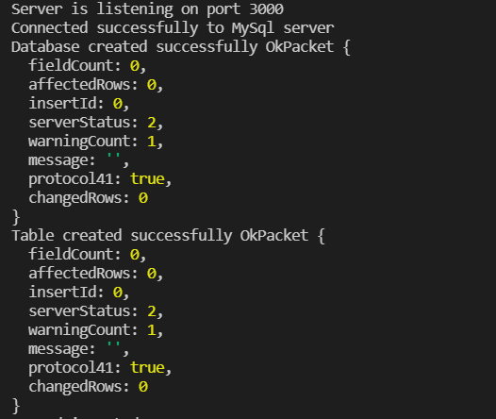

1. localhost:3000/

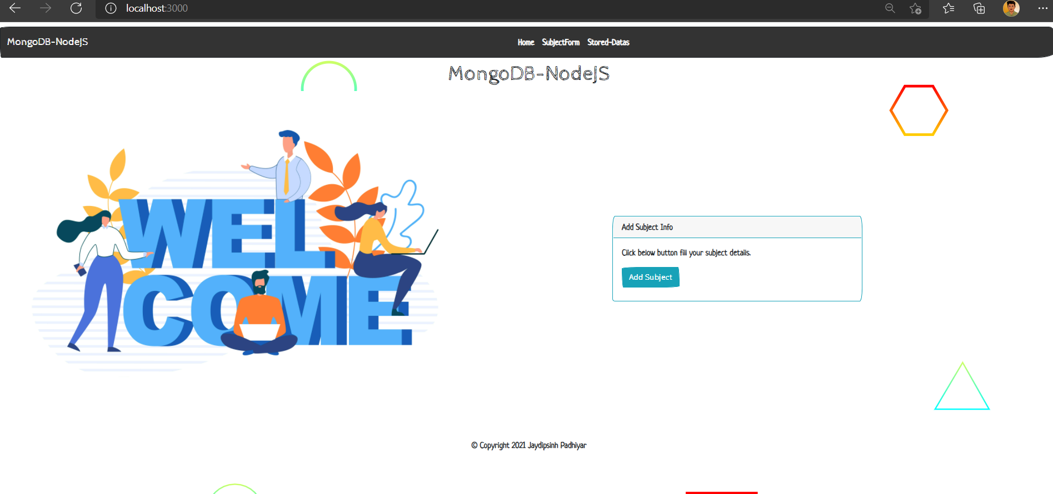

1. localhost:3000/subject-form

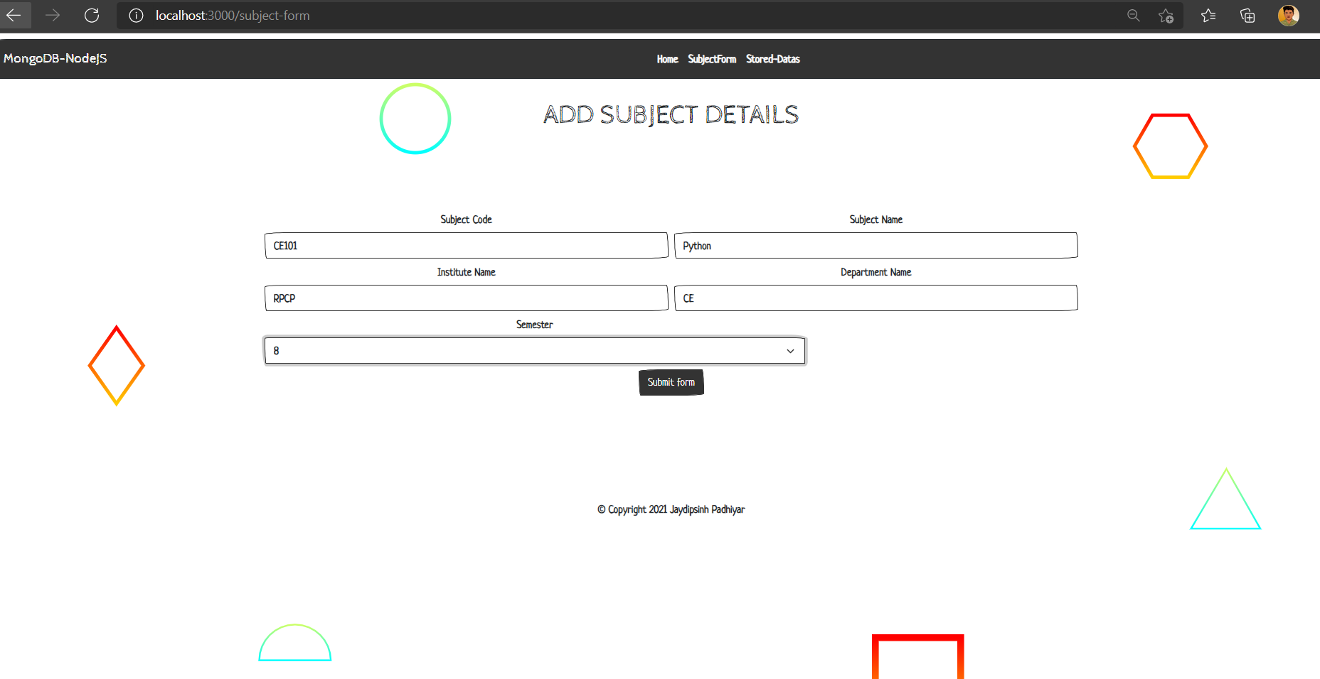

1. localhost:3000/show-data

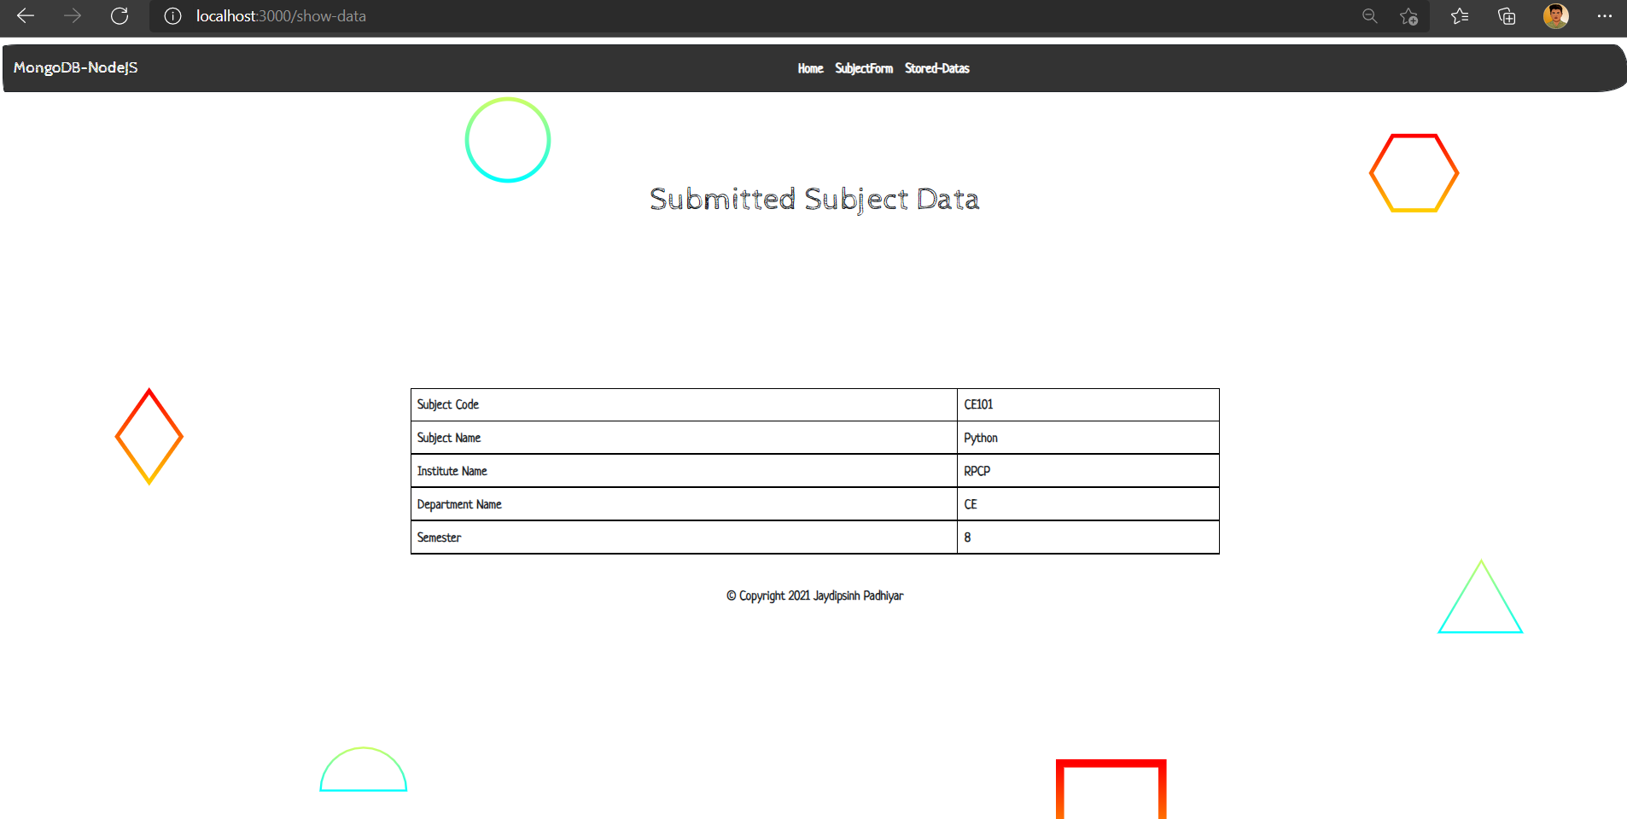

1. localhost:3000/stored-data

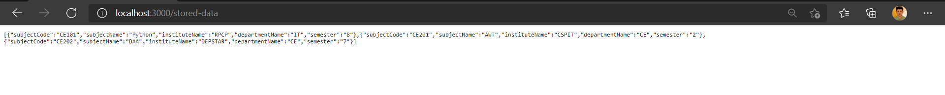

1. MySQL phpmyadmin database:

